1. Let’s define repository for Post Resource.
2. 
3. 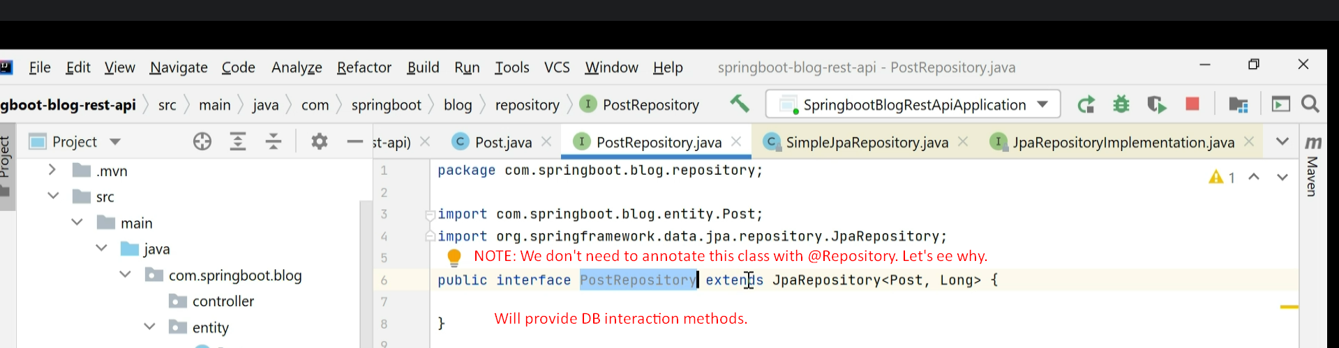
4. 